Hi, Gary

There are several problems here that need to be solved now before we use it officially.

1. These products were changed prices by the supermark this week. Their Chinese names messed up in my computer on both packing slip and invoice are wrong.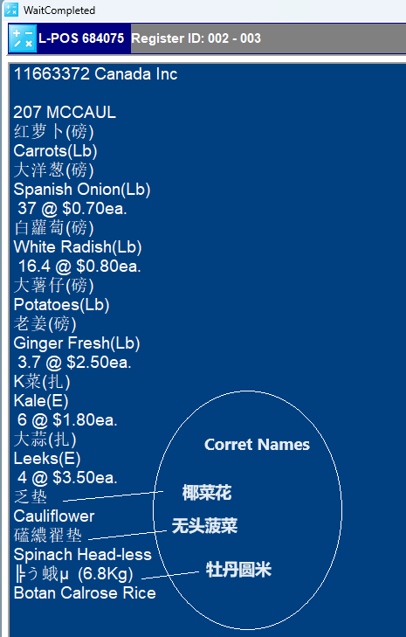
2. **Add a Chinese name column here**

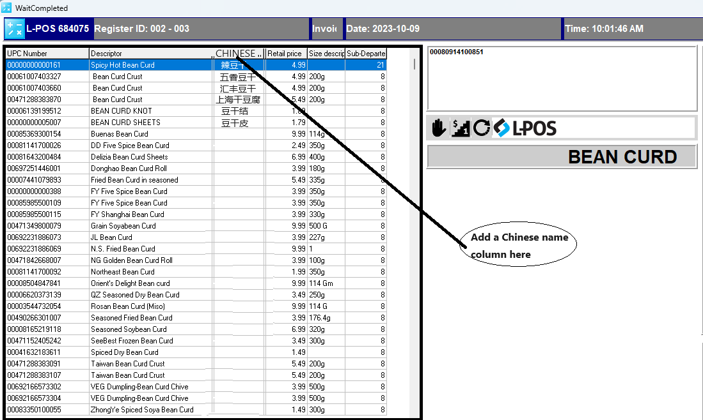

1. 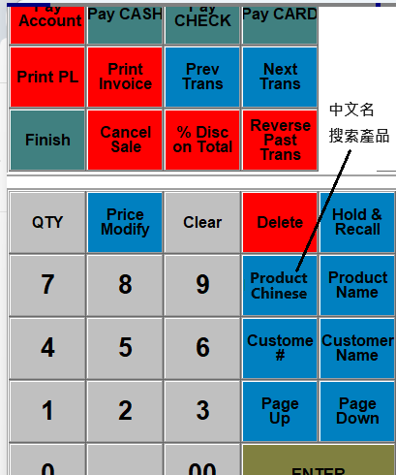
2. There are a large number of temporary database records in the order, payment, and refund tables. We use them for testing purposes before. We need to clear this data before the system is officially used. Can you delete remotely? Or you can send me a SQL statement. I would run it in SQL Server Management Studio to clean up the junk data.